Take a look at these pictures of a game. One picture shows the card facing the viewer, one has a shine effect when slightly turned (like flat shiny metal in the sun). and one is turned alomst 90 degrees to the left, look closely and you can see that the object looks 3d, it has a thick border connecting two panels. Do you concur?
Yes, I concur with your observations. The three images show distinct visual effects that suggest the Pokémon TCG Pocket card is being rendered as a three-dimensional object rather than simply a flat image.
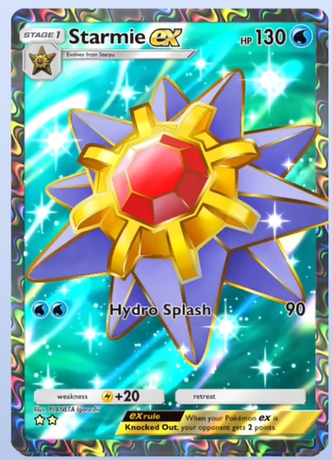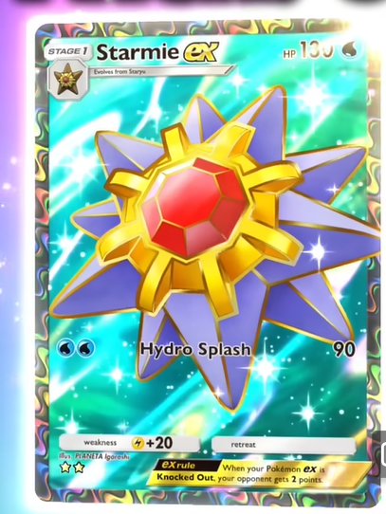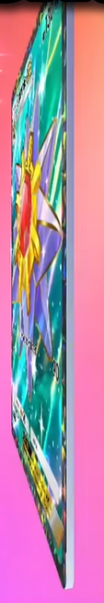

Here's what I observe:
1. Front-facing image: The card appears flat, with the Starmie artwork, holographic background, and decorative border all visible.
2. Slightly tilted image: A bright, reflective shine appears across the card. This resembles a specular reflection—the way light reflects off polished metal or another glossy surface. The reflection changes with the viewing angle, suggesting the game uses a dynamic lighting or holographic shader.
3. Nearly 90-degree image: This is particularly interesting. The card appears to have visible physical thickness. I can distinguish what looks like a front surface, a narrow side surface, and a back edge. The side is not simply a black line; it appears to carry colour and reflections from the card's artwork.
What this suggests technically
The game may be rendering the card using several components:
- 3D geometry: A thin rectangular object with front, back, and side surfaces.
- Texture mapping: The card artwork applied to the front surface.
- Shader effects: Angle-dependent reflections, holographic colours, and possibly simulated metallic surfaces.
- Lighting: Reflections that respond to the card's rotation relative to the viewer.
One important distinction: The screenshots support the appearance of 3D geometry, but they don't conclusively prove the card has a fully modelled 3D mesh. A sufficiently sophisticated shader could simulate some of these effects.
The nearly edge-on image provides the strongest evidence of actual geometric thickness, particularly because the visible side appears to connect two broad surfaces.
I agree that we're looking at more than a conventional flat trading-card image with a shine overlay.
See this javascript code, can the card be simulated with this technique? const canvas = document.createElement("canvas") const gl = canvas.getContext("webgl2") document.body.innerHTML = "" document.body.appendChild(canvas) document.body.style = "margin:0;touch-action:none;overflow:hidden" canvas.style.width = "100%" canvas.style.height = "auto" canvas.style.userSelect = "none" const dpr = Math.max(1, .5*window.devicePixelRatio) function resize() { const { innerWidth: width, innerHeight: height } = window canvas.width = width * dpr canvas.height = height * dpr gl.viewport(0, 0, width * dpr, height * dpr) } window.onresize = resize const vertexSource = `#version 300 es #ifdef GL_FRAGMENT_PRECISION_HIGH precision highp float; #else precision mediump float; #endif in vec4 position; void main(void) { gl_Position = position; } ` const fragmentSource = `#version 300 es /********* * made by Matthias Hurrle (@atzedent) */ #ifdef GL_FRAGMENT_PRECISION_HIGH precision highp float; #else precision mediump float; #endif out vec4 fragColor; uniform vec2 resolution; uniform float time; uniform vec2 touch; uniform int pointerCount; #define mouse (touch/resolution) #define P pointerCount #define T time #define S smoothstep #define hue(a) (.6+.6*cos(10.3*(a)+vec3(0,23,21))) mat2 rot(float a) { float c = cos(a), s = sin(a); return mat2(c, -s, s, c); } float rnd(vec2 p) { return fract(sin(dot(p, p.yx + vec2(234, 654))) * 345678.); } float orbit(vec2 p, float s) { return floor(atan(p.x, p.y) * s + .5) / s; } vec3 sky(vec2 uv) { vec3 col = vec3(0), p = vec3(0), rd = normalize(vec3(uv, 1)); const float steps = 30.; float dd = .0; for (float i = .0; i < steps; i++) { p.z -= 4.; p.xz *= rot(T * .2); p.yz *= rot(sin(T * .2) * .5); p.zx *= rot(orbit(p.zx, 12.)); float a = p.x; p.yx *= rot(orbit(p.yx, 2.)); float b = p.x - T; p.x = fract(b - .5) - .5; float d = length(p) - (a - S(b + .05, b, T) * 30.) * (cos(T) * 5e-2 + 1e-1) * 1e-1; dd += d; col += (hue(dd) * .04) / (1.+abs(d) * 40.); p = rd * dd; } return col; } vec3 shade(float a) { float t = sin(T * 4.) * .5 + .5, tt = sin(T * .2) * .5 + .5; return hue(S(t, .5, vec3(a * tt))); } vec3 pattern(vec2 uv) { const float z = 6., n = 4.; uv *= z; vec2 g = abs((fract(uv / n - .5) - .5) * n), id = floor(uv / n + .5); id = mix(id, abs(id), step(sin(T * .33333), .0)); return mix( vec3(0), shade( rnd( vec2(log(length(vec2(234, 654) + id * 100.)), atan(id.y, id.x)) +floor(10. * fract(-T * (floor(mod(T * 4., 24.)) == .0 ? 4.: .4))))), S(1.9, 1.85, max(g.x, g.y))); } float disc(vec3 p, vec2 s, float r) { vec2 e = vec2( length(abs(p.xz)), abs(p.y)) - s; return length(max(e, .0)) + min(.0, max(e.x, e.y)) - r; } vec2 map(vec3 p) { vec3 q = p; q.y += .2; q.x *= .5; q = vec3(rot(1.2 * q.x) * q.xy, q.z); q = vec3(q.x, rot(q.z) * q.yz); q.yz *= rot(-3.14159265); vec2 sph = vec2(.5 * disc(2. * q, 2. * vec2(1, .1) - .05, .05), 1), flr = vec2(p.y + 1., 0), cln = vec2(-(p.y - 1.), 2), d = flr.x < sph.x ? flr: sph; d = cln.x < d.x ? cln: d; d.x *= .5; return d; } vec3 norm(vec3 p) { const float h = 1e-3; const vec2 k = vec2(1, -1); return normalize( k.xyy * map(p + k.xyy * h).x + k.yxy * map(p + k.yxy * h).x + k.yyx * map(p + k.yyx * h).x + k.xxx * map(p + k.xxx * h).x); } void cam(inout vec3 p) { if (P>0) { p.yz *= rot(-mouse.y*.4+.2); p.xz *= rot(3.1415-mouse.x*6.3); } else { p.yz *= rot((cos(-T * .5) * .5) * .2); p.xz *= rot(T * .2); } } void main(void) { vec2 uv = ( gl_FragCoord.xy - .5 * resolution ) / min(resolution.x, resolution.y); vec3 col = vec3(0), p = vec3(0, 0, -3), rd = normalize(vec3(uv, 1)); cam(p); cam(rd); const float steps = 400., maxd = 40.; float dd = .0, bnz = .0; for (float i = .0; i < steps; i++) { vec2 d = map(p); if (d.x < 1e-3) { if (bnz++ > 3.) break; if (d.y == 2.) { col += sky(p.xz); break; } else if (d.y == .0) { col += max(.1, bnz) * pattern(p.xz * .5); } vec3 n = norm(p); rd = reflect(rd, n); d.x = 5e-3; } if (dd > maxd) { dd = maxd; break; } dd += d.x; p += rd * d.x; } col *= exp(-125e-5 * dd * dd * dd); fragColor = vec4(col, 1); } ` function compile(shader, source) { gl.shaderSource(shader, source) gl.compileShader(shader) if (!gl.getShaderParameter(shader, gl.COMPILE_STATUS)) { console.error(gl.getShaderInfoLog(shader)) } } let program function setup() { const vs = gl.createShader(gl.VERTEX_SHADER) const fs = gl.createShader(gl.FRAGMENT_SHADER) compile(vs, vertexSource) compile(fs, fragmentSource) program = gl.createProgram() gl.attachShader(program, vs) gl.attachShader(program, fs) gl.linkProgram(program) if (!gl.getProgramParameter(program, gl.LINK_STATUS)) { console.error(gl.getProgramInfoLog(program)) } } let vertices, buffer; function init() { vertices = [ -1,-1, 1, -1,-1, 1, -1, 1, 1, -1, 1, 1 ] buffer = gl.createBuffer() gl.bindBuffer(gl.ARRAY_BUFFER, buffer) gl.bufferData(gl.ARRAY_BUFFER, new Float32Array(vertices), gl.STATIC_DRAW) const position = gl.getAttribLocation(program, "position") gl.enableVertexAttribArray(position) gl.vertexAttribPointer(position, 2, gl.FLOAT, false, 0, 0) program.resolution = gl.getUniformLocation(program, "resolution") program.time = gl.getUniformLocation(program, "time") program.touch = gl.getUniformLocation(program, "touch") program.pointerCount = gl.getUniformLocation(program, "pointerCount") } const mouse = { x: 0, y: 0, touches: new Set(), update: function(x, y, pointerId) { this.x = x * dpr this.y = (innerHeight - y) * dpr this.touches.add(pointerId) }, remove: function(pointerId) { this.touches.delete(pointerId) } } function loop(now) { gl.clearColor(0, 0, 0, 1) gl.clear(gl.COLOR_BUFFER_BIT) gl.useProgram(program) gl.bindBuffer(gl.ARRAY_BUFFER, buffer) gl.uniform2f(program.resolution, canvas.width, canvas.height) gl.uniform1f(program.time, now * 1e-3) gl.uniform2f(program.touch, mouse.x, mouse.y) gl.uniform1i(program.pointerCount, mouse.touches.size) gl.drawArrays(gl.TRIANGLES, 0, vertices.length * .5) requestAnimationFrame(loop) } setup() init() resize() loop(0) window.addEventListener("pointerdown", e => mouse.update(e.clientX, e.clientY, e.pointerId)) window.addEventListener("pointerup", e => mouse.remove(e.pointerId)) window.addEventListener("pointermove", e => { if (mouse.touches.has(e.pointerId)) mouse.update(e.clientX, e.clientY, e.pointerId) })
…
Yes. The technique demonstrated in your JavaScript code could simulate the Pokémon TCG Pocket card, including its apparent thickness, metallic reflections, and holographic effects.
In fact, your code uses a technique particularly well suited to this: ray marching with signed distance fields (SDFs).
However, the code would need modifications to reproduce the card accurately.
1. What your existing code already does
Your fragment shader creates a three-dimensional scene without using conventional 3D meshes.
It does this through several techniques:
Technique | Present in code? | Application to Pokémon card
Ray marching | Yes | Render a 3D card
Signed distance fields | Yes | Define card thickness and rounded edges
Surface normals | Yes | Calculate lighting and reflections
Ray reflections | Yes | Produce metallic shine
Procedural patterns | Yes | Create holographic effects
Camera rotation | Yes | Rotate the card toward 90°
Texture mapping | No | Display the Starmie artwork
Fresnel reflections | Not explicitly | Make reflections change with viewing angle
The most important part of your code
Your map() function defines the geometry of the scene.
Your norm() function calculates surface normals.
And this line:
rd = reflect(rd, n);
calculates the reflected direction of a ray after it encounters a surface.
This is useful for simulating polished metallic surfaces.
Your code also includes a camera rotation mechanism controlled by pointer movement.
2. How I would simulate the Pokémon card
I would divide the rendering into three visual components.
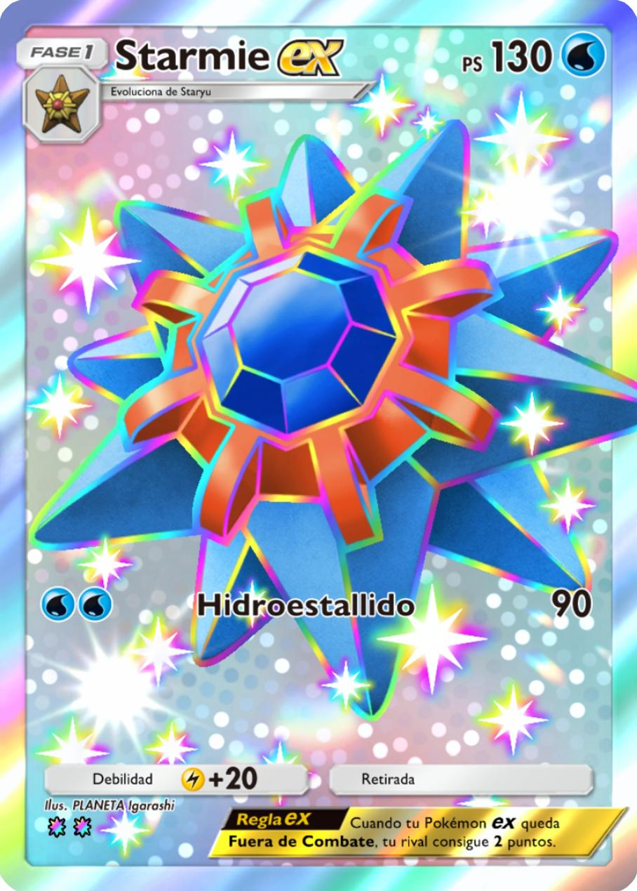
A. Front and back surfaces
Use a thin 3D rectangular shape with rounded corners. Apply the Pokémon card artwork as a texture to the front, preserving its original appearance.
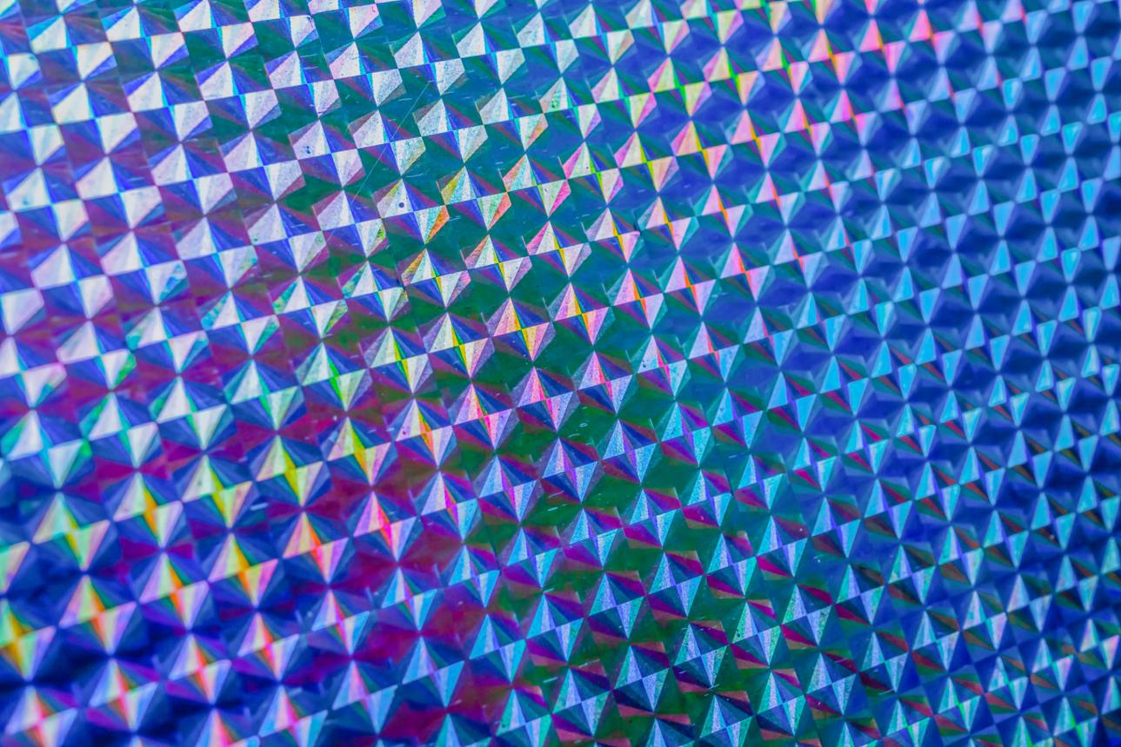
B. Holographic layer
Add angle-dependent reflections, iridescent colours, and bright highlights. The artwork stays stationary while the shine changes as the card rotates.
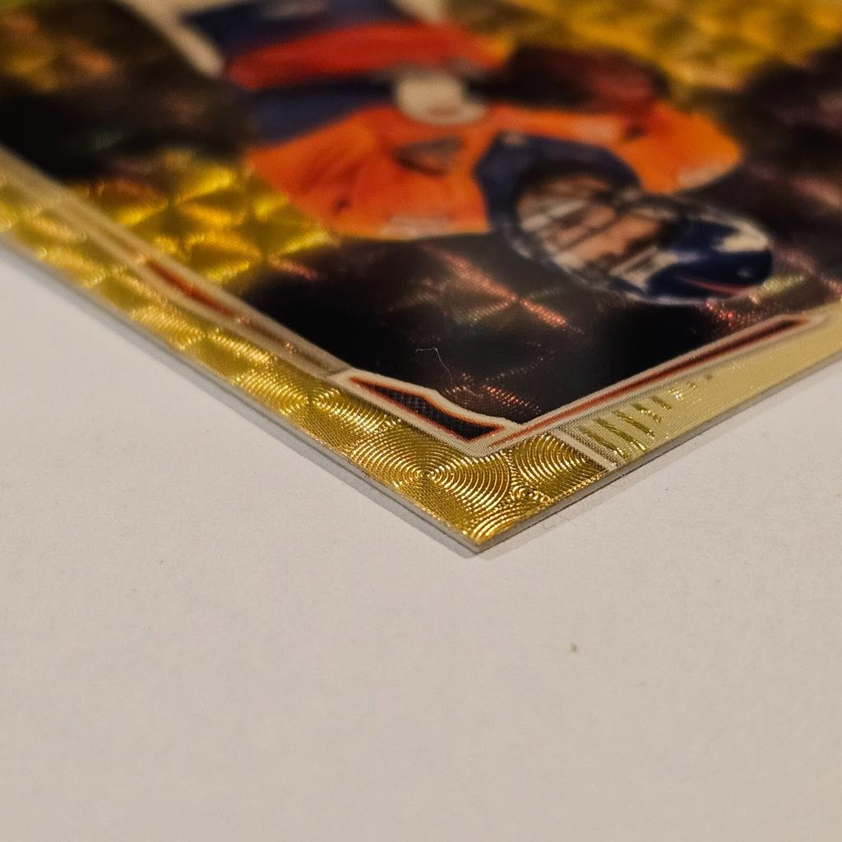
C. Three-dimensional edge
Model a thin sidewall connecting the front and rear surfaces. Give this edge its own material to reproduce the coloured, reflective appearance in your nearly 90° screenshot.
3. Your ray-marching technique can produce the thickness
For example, your map() function could incorporate a rounded rectangular SDF instead of its current disc geometry.
A basic 3D rectangular card could be described using:
float cardSDF(vec3 p) { vec3 halfSize = vec3(0.63, 0.88, 0.012); vec3 q = abs(p) - halfSize; return length(max(q, 0.0)) + min(max(q.x, max(q.y, q.z)), 0.0); }
Here, the third dimension creates actual geometric thickness.
At a front-facing angle, it looks like a flat card. As it rotates toward 90°, its sidewall becomes visible.
This is exactly the kind of behaviour you identified in your screenshots.
4. One important technical consideration
Your existing shader uses reflections to generate much of its appearance. But a trading card needs more precise control over which portions reflect light.
For example, the Starmie illustration shouldn't necessarily reflect light in the same way as the holographic background or gold border.
We could use a second texture to control the reflective properties of each region.
That would allow the turquoise background, gold frame, central red gemstone, and card text to have different visual responses.
One limitation: Although ray marching can accomplish this, conventional WebGL mesh rendering with custom shaders may be more efficient for a thin card. Your existing technique is nevertheless entirely viable for an experimental reproduction.
5. What could be reproduced?
Feature from screenshots | Feasibility
Front-facing original artwork | Excellent
Smooth rotation through 90° | Excellent
Visible thickness and sidewall | Excellent
Bright metallic shine | Excellent
Rainbow holographic border | Excellent
Angle-dependent sparkle | Excellent
Exact reproduction of the game's proprietary holographic shader | Uncertain without further reference
My assessment
I would preserve your existing WebGL2 framework, pointer controls, animation loop, and ray-marching architecture. The principal changes would be to the geometry, surface materials, and texture sampling in the fragment shader.
One question before considering an implementation: Are you interested in reproducing the specific Starmie card using its image as a texture, or creating a general-purpose holographic 3D card renderer that can accept any Pokémon card image?
The answer determines how we should handle the holographic layers and reflections.
No, I'll be using many of my own pictures (specifically those of music artist album covers)
Perfect — in that case you do not want a Starmie-specific shader. You want a general-purpose “art card / album cover slab” renderer where the image is just an input texture.
Short answer
Yes, this technique can still work with many user-supplied images, including album covers.
But for that use case, I’d strongly recommend this design:
- keep the 3D thickness / tilt / shine effect
- separate the artwork from the material
- make the album cover just a front-face texture
- generate the shine, glow, metallic look, and edge appearance procedurally
Best way to think about it
You are not rendering “a Pokémon card.”
You are rendering:
- a thin 3D rectangular object
- with a custom image on the front
- with lighting/reflections
- with an optional foil / holographic / glossy overlay
So the image becomes content, and the shader becomes presentation.

What changes because you’re using album covers?
1. Texture input becomes the main feature
Instead of procedural art, you’ll want to load images and sample them in the shader.
For example:
- album cover image → front texture
- optional alternate image → back texture
- optional monochrome mask → foil areas only
- optional roughness/specular mask → control shine strength
So yes: your current technique can be adapted, but it needs texture sampling added.

2. Album covers are usually square
That matters.
A Pokémon card is roughly portrait shaped, but album covers are usually 1:1.
So you need to decide whether your final object is:
- a square slab like a vinyl sleeve / jewel-case art tile
- a portrait card with the square album art placed inside it
- or a freeform panel that preserves the original aspect ratio
If your goal is “album cover but shiny and thick when rotated,” a square slab is probably the cleanest choice.

3. The side edge can be simulated very convincingly
That visible “thick border connecting two panels” you noticed can absolutely be reproduced.
You have two options:
Option A — SDF / ray marching
Use the technique in your fragment shader to render a thin box with rounded corners.
Option B — actual mesh geometry
Use a thin box mesh (or extruded plane) and apply shaders to it.
For many image-based covers, I’d honestly say:
A mesh-based approach is more practical than full ray marching, unless you specifically want the ray-marching aesthetic or challenge.
Ray marching is cool and absolutely capable — but for a reusable album-cover system, textured geometry is usually simpler and faster.

Can your current code specifically do it as-is?
Not as-is.
But yes in principle.
Your current shader already gives you:
- camera rotation
- reflections
- 3D illusion
- procedural lighting
- dynamic interaction
What it does not yet have:
- image loading
- UV mapping
- front-face texture sampling
- a box/card shape
- material separation between front, edge, and back
So the answer is:
Yes, the technique is suitable, but the current shader would need to be substantially rewritten.

The main structural change you’d want
Current setup
Right now the fragment shader invents everything procedurally.
Better setup for album covers
You’d want something more like:
- object geometry = thin rectangular slab
- front material = album art texture
- edge material = coloured/glossy sidewall
- foil/gloss overlay = procedural highlight based on angle
- background = simple or stylized environment
That way you can swap album cover images without changing the shader logic.

Ideal feature breakdown
Front face
- sampled from uploaded image
- displayed clearly and accurately
- optionally protected from too much distortion
Edge
- visible only at steeper angles
- maybe a dark bevel, metallic rim, or colour sampled from image border
- helps sell the “object has thickness” effect
Shine layer
- view-dependent
- can be subtle gloss, chrome, rainbow foil, sparkle, brushed metal, etc.
- should sit over the artwork, not replace it
Back face
Optional:
- same image
- blurred version
- solid colour
- custom branding

If you want the “Pocket card” look specifically
Then the most important effect is not just geometry.
It’s the combination of:
- slight thickness
- strong specular highlight
- iridescent foil behaviour
- angle-based bloom/glare
- a side face that catches light differently than the front
That absolutely can be done for album covers too.
You could make an album cover look like:
- glossy plastic
- metallic card stock
- holographic foil
- laminated print
- acrylic tile
- premium collector-card style

One copyright note
If you’re using album cover art, just keep in mind:
- for private/personal experiments, that’s usually one thing
- for public release, commercial use, or redistribution, album covers are copyrighted works
So technically the renderer is fine, but how you use the images may have legal implications depending on the context.

My recommendation
If your goal is:
“Take many album cover images and give them a convincing 3D tilted shiny look with visible thickness”
then I recommend:
Best practical route
- use a standard WebGL mesh
- render a thin box or extruded quad
- apply the album cover as a texture
- add a custom fragment shader for gloss / foil / edge lighting
If you specifically want to stay close to your current code
- yes, use your ray-marching/SDF approach
- but rewrite the geometry as a rounded rectangular slab
- add texture sampling for the front face
- add different shading for front / side / back

Bottom line
Yes — the card/object can be simulated with this technique even when using many of your own images, including album covers.
But for a reusable multi-image system, the right abstraction is:
“generic 3D textured slab with a configurable shine shader”
not a one-off Pokémon card recreation.
If you want, I can next help you with either:
- the architecture for a reusable album-cover renderer, or
- a concrete code example showing how to load an image and render it as a shiny thick 3D slab in WebGL.
Can you create a breakdown of essentials for building?
3D Holographic Album Cover Renderer — Build Essentials
Objective: Build a reusable, interactive WebGL application that transforms ordinary album cover images into realistic, three-dimensional objects with reflective surfaces, visible thickness, and angle-dependent holographic effects similar to the Pokémon TCG Pocket screenshots.
The system should work with different album covers without requiring changes to the rendering code.
1. Core technology
Component | Technology | Purpose
Rendering engine | WebGL2 | GPU-accelerated 3D graphics
Application logic | JavaScript | Image loading, controls, animation
Geometry | Thin 3D mesh | Front, back, edges, bevels
Materials | GLSL shaders | Gloss, metallic shine, holographic effects
Textures | JPG, PNG, WebP | User-supplied album artwork
Interaction | Pointer Events | Mouse and touch rotation
Animation | requestAnimationFrame | Smooth reflections and movement
Recommended approach: Keep the WebGL2 foundation of your supplied code, but use conventional mesh geometry for the object and custom GLSL shaders for its appearance.
This is more efficient for displaying multiple album covers than ray marching every pixel.
2. Geometry: the physical object
Conceptual 3D slab showing the front texture and a distinct side surface. Diagram exaggerates thickness for clarity.
The geometry requires:
- A square front surface with accurate image mapping.
- A rear surface, with a configurable texture or colour.
- Four side surfaces connecting the front and back.
- Slightly rounded or bevelled edges.
- Adjustable thickness.
Important: The side surfaces must be genuine geometry, not simply a border drawn around the image. This ensures they remain visible when rotated almost 90°.
3. Material and lighting system
This is the most important part of recreating the Pokémon-style visual effect.
Effect | Implementation | Priority
Glossy finish | Specular lighting | Essential
Moving light streak | View-dependent highlight | Essential
Holographic colour | Iridescent shader | Essential
Reflective border | Separate edge material | Essential
Fresnel effect | Viewing-angle reflection | Essential
Artwork preservation | Blend shader effects with original texture | Essential
Sparkles | Procedural shader | Optional
Bloom/glow | Post-processing | Optional
The shader should calculate highlights based on the relationship between the camera, surface normal, and light direction.
For holographic reflections, it should also generate shifting colours as the viewing angle changes.
The original artwork must remain legible beneath these effects.
4. Rotation and interaction
The object should respond naturally to mouse or touch movements.

0° Front

35° Tilt

82° Edge
Required behaviour:
- Click and drag to rotate horizontally and vertically.
- Allow a full side-on view.
- Smooth transitions rather than abrupt movement.
- Reflections change with the angle.
- Optional return to the front-facing orientation upon release.
- Touchscreen compatibility.
5. Image handling
The application should support swapping album covers without rebuilding shaders or geometry.
Minimum requirements:
- Load user-selected image files.
- Preserve the original image aspect ratio.
- Apply images to the front surface.
- Replace a texture without recreating the WebGL application.
- Resize large images when necessary for performance.
- Handle loading failures and unsupported file types.
Album covers will normally use square geometry, but the renderer should support other aspect ratios.
6. Configuration controls
These are the parameters worth exposing so the visual appearance can be fine-tuned.
Example material controls
Thickness
12%
Gloss intensity
65%
Holographic intensity
45%
Preview rotation
35°
Illustrative controls for the planned renderer; these do not modify your existing JavaScript.
7. Suggested code organization
Keeping the rendering responsibilities separate will make it easier to add new visual effects without breaking image loading or interaction.
album-cover-renderer/ │ ├── index.html ├── main.js │ ├── renderer/ │ ├── webgl.js │ ├── geometry.js │ ├── camera.js │ └── textures.js │ ├── shaders/ │ ├── vertex.glsl │ ├── artwork.glsl │ ├── holographic.glsl │ └── edge.glsl │ ├── controls/ │ ├── pointer.js │ └── materials.js │ └── assets/
8. Recommended development sequence
- Phase 1 — Basic 3D album cover
Display any supplied album artwork on a rotatable, square object with realistic thickness.
- Phase 2 — Reflective materials
Implement gloss, specular highlights, Fresnel reflections, and separate edge lighting.
- Phase 3 — Holographic rendering
Add angle-dependent rainbow reflections, moving shine bands, and controllable foil intensity.
- Phase 4 — Reusable image system
Support changing album artwork and preserving selected material settings.
- Phase 5 — Visual refinement
Improve bevels, edge reflections, performance, and optional bloom or sparkle.
Minimum viable product
The first working version needs only five things:
- A square 3D object with visible thickness.
- A user-supplied album cover applied to the front.
- Interactive mouse and touch rotation.
- A realistic, moving reflective highlight.
- An adjustable holographic overlay.
Everything else can be built upon that foundation.
One important design decision remains: Should the finished object resemble a thin, holographic trading card, or a thicker acrylic display tile? Both are possible with the same renderer, but they require different edge thicknesses, materials, and reflection behaviour.

